Section I: Scenario Demographics

Scenario Title: | Congenital Heart Disease
Date of Development: | 25/02/2016 (DD/MM/YYYY)
Target Learning Group: | Juniors (PGY 1 – 2) Seniors (PGY ≥ 3) All Groups

Section II: Scenario Developers

Scenario Developer(s): | Dr. Quang Ngo & Dr. Donika Orlich
Affiliations/Institution(s): | McMaster University
Contact E-mail (optional): | Donika.orlich@medportal.ca

Section III: Curriculum Integration

Learning Goals & Objectives
Educational Goal: | To expose learners to neonatal shock due to severe coarctation of the aorta.
CRM Objectives: | - Demonstrates good problem solving including quick implementation of concurrent management plans  - Demonstrates situational awareness by avoiding fixation error and anticipating likely events
Medical Objectives: | - Employs a structured approach to the investigation and management of cyanosis in a neonate  - Initiates treatment for likely ductal dependent cardiac lesion  - Anticipates the complications of PGE infusion and implements a rational approach to intubation in the neonate

Case Summary: Brief Summary of Case Progression and Major Events
A 2 week old neonate presents in shock requiring the learner to implement an initial broad work-up. The patient will also be hypoglycemic, and will seize if this is not promptly recognized. Physical exam and CXR findings will suggest coarctation of the aorta as the likely cause, and the learner should recognize the need for gentle fluid boluses and a PGE infusion. The infant will become apneic after starting the PGE infusion, requiring intubation.

References
Marx, J. A., Hockberger, R. S., Walls, R. M., & Adams, J. (2013). Rosen's emergency medicine: Concepts and clinical practice. St. Louis: Mosby.
Al Balushi A, Zacharias S, Al Senaidi K. Coarctation of the Aorta, Known Yet Can Be Missed. Oman Med J 2013 May; 28(3):204-206. Available from http://www.omjournal.org/fultext_PDF.aspx?DetailsID=380&type=fultext

Section IV: Scenario Script

A. Scenario Cast & Realism
Patient: | Neonatal Computerized Mannequin |  |  |  |  | Realism:  Select most important dimension(s) |  |  | Conceptual
 | Mannequin |  |  |  |  |  |  |  | Physical
 | Standardized Patient |  |  |  |  |  |  |  | Emotional/Experiential
 | Hybrid |  |  |  |  |  |  |  | Other:
 | Task Trainer |  |  |  |  |  |  |  | N/A
Confederates | Brief Description of Role
Mother: | Brought patient to the ED as she was worried because her son hasn’t been feeding very well. After vomiting the last feed, she noticed he was quite lethargic and seemed a strange colour.  ROS: no fever, no diarrhea, no sick contacts, no urine since last night  PMHx: mother G3P3; uncomplicated pregnancy, GBS neg, delivered SVD at 38 weeks; no meconium, no PROM, no birth complications and left on day 2 of life, breastfeeding
B. Required Monitors
EKG Leads/Wires |  |  | Temperature Probe |  |  |  | Central Venous Line
NIBP Cuff |  |  | Defibrillator Pads |  |  |  | Capnography
Pulse Oximeter |  |  | Arterial Line |  |  |  | Other:
C. Required Equipment
Gloves |  |  | Nasal Prongs |  |  |  | Scalpel
Stethoscope |  |  | Venturi Mask |  |  |  | Tube Thoracostomy Kit
Defibrillator |  |  | Non-Rebreather Mask |  |  |  | Cricothyroidotomy Kit
IV Bags/Lines |  |  | Bag Valve Mask |  |  |  | Thoracotomy Kit
IV Push Medications |  |  | Laryngoscope |  |  |  | Central Line Kit
PO Tabs |  |  | Video Assisted Laryngoscope |  |  |  | Arterial Line Kit
Blood Products |  |  | ET Tubes |  |  |  | Other:
Intraosseous Set-up |  |  | LMA |  |  |  | Other:
D. Moulage
None

E. Approximate Timing
Set-Up: |  | 5 min |  | Scenario: | 20 min |  |  | Debriefing: |  | 40 min

Section V: Patient Data and Baseline State

A. Clinical Vignette: To Read Aloud at Beginning of Case
Your triage nurse comes to tell you about an infant she just put in the resuscitation room who she feels looks quite unwell. Sam is a 2 week old neonate brought to the ED by his mother. She was worried because he hasn’t been feeding very well. He seems to just get sleepy when feeding. Now he just vomited his last feed and seems really lethargic. She thinks he just “doesn’t look the right colour”.
B. Patient Profile and History
Patient Name: Sam Lodger |  |  |  |  |  | Age: 2 weeks |  |  |  |  |  |  |  | Weight: 3kg
Gender: M F |  |  |  |  |  | Code Status: Full Code
Chief Complaint: Vomiting
History of Presenting Illness: As above by mother.
Past Medical History: |  | None |  |  |  |  | Medications: |  |  |  |  | None
 |  | Born 38 weeks GA (SVD)
Allergies: None
Social History: Lives with mom and dad. 2 Older siblings at home.
Family History: No hx CHD, inborn errors of metabolism, endocrine disorders. Mother healthy
Review of Systems: |  | CNS: |  |  | Mom feels he is much more lethargic than usual.
 |  | HEENT: |  |  | Nil
 |  | CVS: |  |  | Nil
 |  | RESP: |  |  | Nil
 |  | GI: |  |  | Poor feeding. Vomited the last feed. No diarrhea. No hematochezia.
 |  | GU: |  |  | No wet diaper since last night
 |  | MSK: |  |  | Nil |  |  |  |  |  |  |  | INT: |  | Cool skin. ? normal color
C. Baseline Simulator State and Physical Exam
No Monitor Display |  |  |  | Monitor On, no data displayed |  |  |  |  |  |  | Monitor on Standard Display
HR: 180/min |  |  | BP: 80/40 (R arm) |  |  |  |  | RR: 50/min |  |  |  |  |  |  | O₂SAT: 94 %
Rhythm: NSR |  |  | T: 36.0ºC |  |  |  |  | Glucose: 1.5mmol/L |  |  |  |  |  |  | GCS: 12 (E2 V4 M6)
General Status: Grunting and very lethargic infant.
CNS: | Floppy and lethargic with little response. Moving limbs symmetrically
HEENT: | PERLA 2mm. No signs HI. Fontanelle sunken.
CVS: | Normal S1, S2. No murmurs. Weak lower limb and femoral pulses, normal upper limb pulses.  4 limb BPs – RA 80/40 LA 82/44 RL 65/35 LL 67/40
RESP: | Crackles to the bases. No increased work of breathing. Tachypneic.  O2 Sats- RA 94% LL 89%
ABDO: | Soft. No distension. No apparent discomfort.
GU: | Nil
MSK: | No signs abuse. |  |  |  |  |  |  |  | SKIN: | Delayed CRT 4 sec and grey appearance

Section VI: Scenario Progression
Scenario States, Modifiers and Triggers
Patient State | Patient Status | Learner Actions, Modifiers & Triggers to Move to Next State
1. Baseline State  Rhythm: NSR  HR: 180/min  BP: 80/40  RR: 50/min  O₂SAT: 94%  T: 36ºC  **BP cuff and O2 probe both start on right arm. Unless asked for 4 limb BPs, will not move cuff to check other limbs. | Lethargic.  Opens eyes to pain. Moves spontaneously. Weak moaning. Looks grey with delayed cap refill. Some peripheral cyanosis. | Learner Actions  - Monitors, insert iv  - 100% O2  - Cap Glucose (1.5mmol/L)  - D10 bolus (5cc/kg) for hypoglycemia  - IV NS bolus (10cc/kg)  - Broad Antibiotics (Ampicillin + Cefotaxime)  - Labs (basic + lactate + VBG + ammonia + LFTs + BC)  - Check 4 limb BP’s  - CXR  - ECG  - Early consult of PICU, RT  - Delegate team member to take history from mother & update her | Modifiers  Changes to patient condition based on learner action  - 100% O2 no improvement in distal cyanosis  Triggers  For progression to next state  - Hypoglycemia not recognized by 3 mins 2. Seizure  - 5 mins 3. Hypotension
2. Seizure  Rhythm: NSR  HR: 190/min  BP: 90/50  RR: 10/min  O₂SAT: 97% | Patient begins to seize | Learner Actions  - Cap glucose (1.5)  - D10 bolus (5cc/kg) | Modifiers  - IV benzo continues to seize  - D10 bolus seizure stops  Triggers  - Hypoglycemia corrected 3. Hypotension
3. Hypotension  Rhythm: NSR  HR: 190/min  BP: 55/40 legs,  65/35 arms  RR: 25/min  O₂SAT: 98% | More lethargic. Eyes open only to pain. No verbal response. Flexion to pain.  Cap refill now 6s (more grey) | Learner Actions  - IV NS bolus (10cc/kg) x3  - Anticipate need for Dopamine (5mcg/kg/min) OR Epi (0.05mcg/kg/min)  - Plan for intubation (anticipate apnea with PGE1)  - Chose correct tube size (3.5 uncuffed, 3.0 cuffed)  - ± Pretreat with atropine (0.2mg/kg)  - Etomidate ideal agent  - Paralytic  - Post-intubation sedation (midazolam)  - Start PGE 1 infusion (0.05-0.1mcg/kg/min) | Modifiers  - Nurse to prompt re: 4 limb BP’s if not yet done  - 1st NS bolus HR 185, BP 58/40  - 2nd bolus HR 180, BP 60/45  - 3rd bolus HR 170, BP 65/48  Triggers  - Intubation without atropine  4. Bradycardia  - Intubation + PGE1 started  7. Resolution  - PGE1 without intubation  5. Apnea  - No PGE1 started by 5 mins  6. Arrest
4. Bradycardia  O₂SAT 95% over 1 min of bagging  HR 70 over 1 min  BP 40/20 | Baby becomes less responsive. | Learner Actions  - Give atropine 0.02mg/kg iv (0.56mg)  - Plan for intubation (as above)  - Start PGE 1 infusion (0.05-0.1mcg/kg/min) if not already given | Modifiers  - Atropine given HR 160, O2 98%  Triggers  - No atropine given by 3 mins 6. Arrest  - No PGE1 started by 5 mins 6. Arrest  - Intubated and PGE1 started 7. Resolution
5. Apnea  O₂SAT 90% over 1 min of bagging  RR 3 over 1 min  HR: 170  BP: 55/40 | Baby stops breathing | Learner Actions  - Start BMV ventilation  - Plan for intubation (as above) | Modifiers  - If not considering intubation, slowly decrease O2 stats 85%  Triggers  - Intubation 7. Resolution
6. Arrest  HR: 35  BP: 40/20  O2: 92% NRB/BMV  RR: 8  ETCO2: 10 | Baby becomes unresponsive | Learner Actions  - BMV ventilate  - Start chest compressions (depth = ½ AP diameter of chest)  - 15:2 compressions to breaths (8 breaths/min if intubated)  - Recheck glucose (5.2)  - IV NS bolus (10cc/kg)  - Epinephrine (0.01mg/kg q3min)  - Plan for intubation (as above)  - Atropine (0.02mg/kg) if from state 4. Bradycardia  - Start PGE 1 infusion (0.05-0.1mcg/kg/min) if not already started | Modifiers  - BMV ventilation no change  - Chest Compressions ETCO2 20  Triggers:  - If cause of arrest no PGE1, once PGE1 started + intubation  7. Resolution  - If cause of arrest no atropine, once atropine given + intubated  7. Resolution
7. Resolution  HR: 150/min  BP: 80/40  RR: 20/min (vented)  O₂SAT: 99%  T: 36ºC | Patient intubated and sedated | Learner Actions  - Post-intubation CXR  - Update ICU  - Consult Cardiac Sx  - Update mother | Triggers  - 20 mins or all actions complete END CASE

Section VII: Supporting Documents, Laboratory Results, & Multimedia

Laboratory Results
Na: 140 | K: 5.6 |  |  | Cl: 105 |  | HCO₃: 25 |  | BUN: 5 |  | Cr: 80 |  |  | Glu: 1.5
Ca: 2.50 |  |  | Mg: 0.8 |  |  |  | PO₄: |  |  |  | Albumin: 35
VBG |  | pH: 7.29 |  |  | PCO₂: 50 |  | PO₂: 95 |  | HCO₃: 18 |  |  | Lactate: 3.0
WBC: 18 |  |  | Hg: 140 |  |  |  | Hct: 0.4 |  |  |  | Plt: 550
Images (ECGs, CXRs, etc.)
Initial CXR (CHF, cardiomegaly)  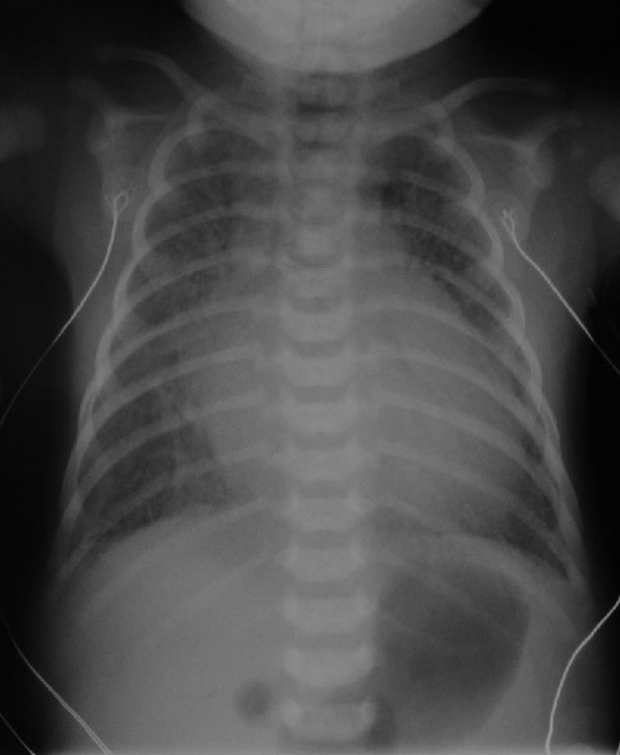  CXR source: http://www.adhb.govt.nz/newborn/TeachingResources/Radiology/CXR/HLHS/CXR-HLHS-congested.jpg | Post-intubation CXR  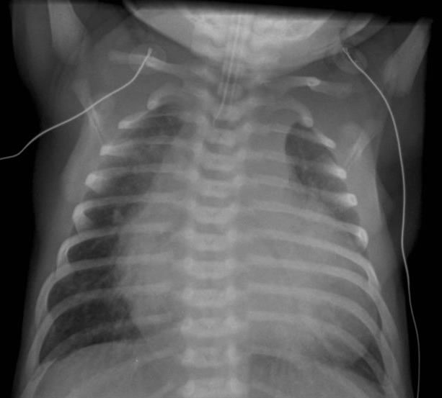  CXR source: http://www.adhb.govt.nz/newborn/TeachingResources/Radiology/CXR/OtherCHF/NonstructuralCHF.jpg
ECG (sinus rhythm, extreme right-axis deviation)
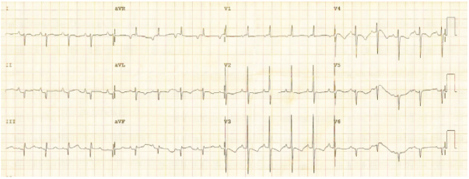

ECG source:
http://www.omjournal.org/IssueText.aspx?issId=380
Ultrasound Video Files (if applicable)
None

Section VIII: Debriefing Guide

General Debriefing Plan
Individual | Group |  | With Video | Without Video
Objectives
Educational Goal: |  | To expose learners to neonatal shock due to severe coarctation of the aorta.
CRM Objectives: |  | - Demonstrate good problem solving including quick implementation of concurrent management plans considering alternatives during crisis  - Demonstrates situational awareness, avoiding fixation error, anticipating likely events, and constantly reassessing the situation  - Demonstrates leadership skill by staying calm during crisis to maintain a global perspective and demonstrate prompt decision making
Medical Objectives: |  | - Employs a structured approach to the investigation and management of cyanosis in a neonate  - Initiates treatment for likely ductal dependent cardiac lesion  - Anticipates the complications of PGE infusion and implements a rational approach to intubation in the neonate
Sample Questions for Debriefing
- What is your initial DDx for neonatal shock? What antidotes/treatments can be initiated immediately in these patients?
- What was your approach to hypotension for this patient? How might your approach to fluid resuscitation change in a patient in whom CHD is likely?
- What features on Hx, PE, CXR and ECG suggested the diagnosis of coarctation of the aorta?
- What are the ductal dependent lesions? How are these managed in the ED?
- What are common complications of prostaglandin infusion?
- What are the clinical features of congenital heart disease? When should it be suspected in infants presenting to the ED? How was this patient the same? How was this patient different?
Key Moments
- Recognition of likely cardiac cause to cyanosis and initiation of PGE1 infusion for possible ductal dependent lesion
- Tailored approach to fluid resuscitation and vasopressor choice given likely CHD
- Anticipating need for intubation given apnea as a common side effect to PGE1 infusion

